CREATE USER 'root'@'localhost' IDENTIFIED BY 'Sant@023';

CREATE DATABASE auth;

GRANT ALL PRIVILEGES ON auth.* TO 'root'@'localhost';

#GRANT ALL PRIVILEGES ON auth.* TO 'root'@'localhost';

USE auth;

CREATE TABLE user (

id INT NOT NULL AUTO_INCREMENT PRIMARY KEY,

email VARCHAR(255) NOT NULL UNIQUE,

password VARCHAR(255) NOT NULL

);

INSERT INTO user (email, password) VALUES ('georgio@email.com', 'Admin123');

G:\Learning-Skills\PythonProjects\microservices-python-main\src\auth>mysql -u root -p

Enter password: ********

Welcome to the MySQL monitor. Commands end with ; or \g.

Your MySQL connection id is 55

Server version: 8.0.43 MySQL Community Server - GPL

Copyright (c) 2000, 2025, Oracle and/or its affiliates.

Oracle is a registered trademark of Oracle Corporation and/or its

affiliates. Other names may be trademarks of their respective

owners.

Type 'help;' or '\h' for help. Type '\c' to clear the current input statement.

mysql -uroot < init.sql

mysql> show databases;

+--------------------+

| Database |

+--------------------+

| auth |

| information_schema |

| mysql |

| performance_schema |

| sakila |

| sys |

| world |

+--------------------+

7 rows in set (0.07 sec)

mysql> use auth

Database changed

mysql> show tables;

+----------------+

| Tables_in_auth |

+----------------+

| user |

+----------------+

1 row in set (0.03 sec)

mysql> describe user;

+----------+--------------+------+-----+---------+----------------+

| Field | Type | Null | Key | Default | Extra |

+----------+--------------+------+-----+---------+----------------+

| id | int | NO | PRI | NULL | auto_increment |

| email | varchar(255) | NO | UNI | NULL | |

| password | varchar(255) | NO | | NULL | |

+----------+--------------+------+-----+---------+----------------+

mysql> select * from user;

+----+-------------------+----------+

| id | email | password |

+----+-------------------+----------+

| 1 | santosh@email.com | Admin123 |

+----+-------------------+----------+

1 row in set (0.00 sec)

/******************************************************************************/

pip3 freeze > requirements.txt

G:\Learning-Skills\PythonProjects\microservices-python-main\src\auth>docker build .

=> exporting to image 12.3s

=> => exporting layers 5.7s

=> => exporting manifest sha256:866d01336abde0b38ae80adcae8ad70473afeddebca4939ab45920ee127ad547 0.0s

=> => exporting config sha256:69f3ede6843f2a276933231e2def30aeef93abf289b7fbbccc0f982a157beca9 0.0s

=> => exporting attestation manifest sha256:59ce95ec024651df706a21edba50dab7abcb33e3bc5f61dacc9123186e6cc7b9 0.1s

=> => exporting manifest list sha256:c3913981c9b372289c86be6dde23e448e4300f30199d52a86d0c0514f28e591f 0.1s

=> => naming to moby-dangling@sha256:c3913981c9b372289c86be6dde23e448e4300f30199d52a86d0c0514f28e591f 0.0s

=> => unpacking to moby-dangling@sha256:c3913981c9b372289c86be6dde23e448e4300f30199d52a86d0c0514f28e591f 6.1s

View build details: docker-desktop://dashboard/build/desktop-linux/desktop-linux/f6yzbytk4v9i45min8ljv3qgd

G:\Learning-Skills\PythonProjects\microservices-python-main\src\auth>docker tag <image sha256:<code>>

docker tag c3913981c9b372289c86be6dde23e448e4300f30199d52a86d0c0514f28e591f skg023/auth:latest

docker push skg023/auth:<tagname>

docker push skg023/auth:latest

G:\Learning-Skills\PythonProjects\microservices-python-main\src\auth\manifests>minikube start

G:\Learning-Skills\PythonProjects\microservices-python-main\src\auth\manifests>kubectl apply -f ./

/***********************************************************************************/

mkdir gateway

python3 -m venv venv

source .venv/bin/active

env | grep ENV

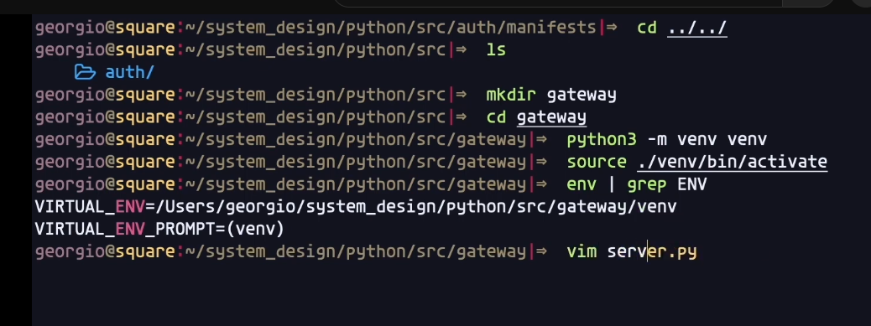

pip install jedi

pip install pylint

cat server.py

pip install pika

pip install pyMongo

pip install Flask-PyMongo

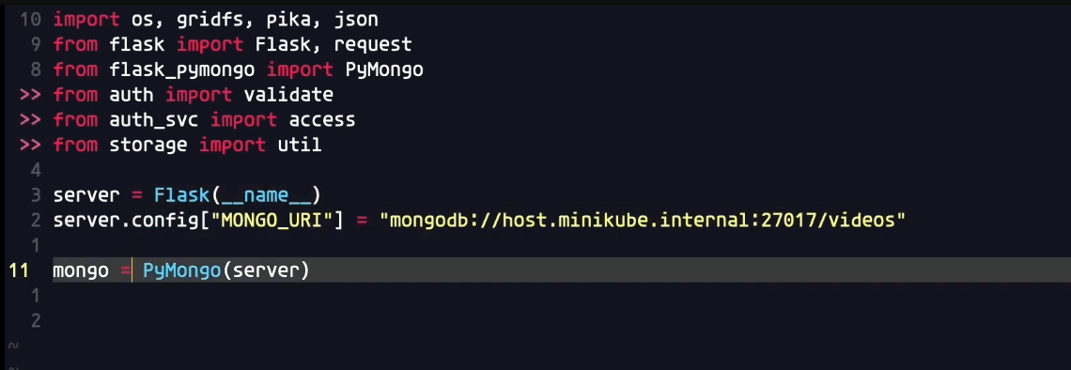

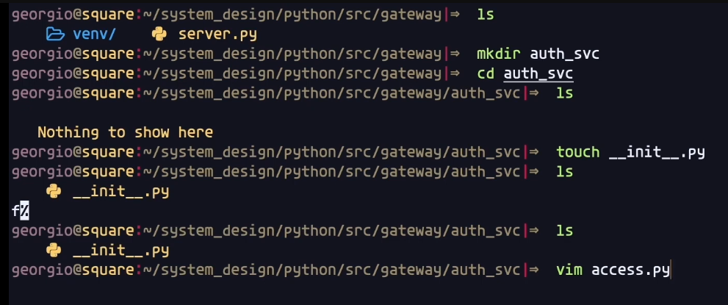

pip install requests

env | grep ENV

**sudo vim etc/hosts**

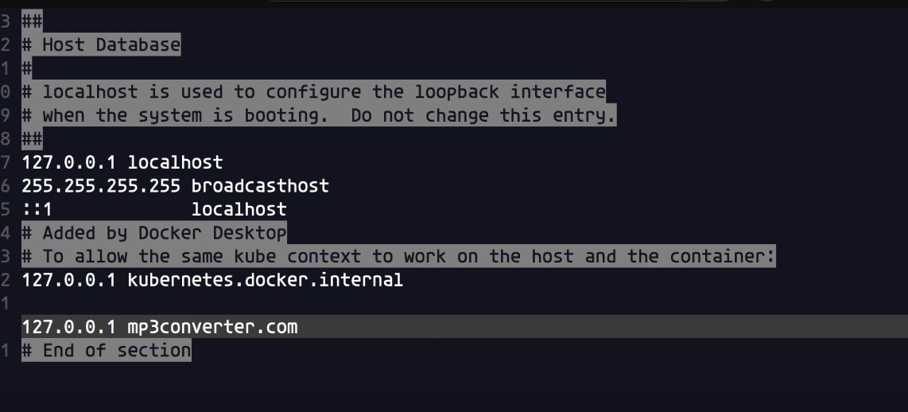

minikube addons list

